**PAMANTASAN NG LUNGSOD NG MAYNILA**

(

University of the City of Manila

)

Intramuros, Manila



**Microprocessor Lab**

Laboratory Activity No. 1

# Familiarization with TinkerCAD

|  |
| --- |
|  |

Score

*Submitted by:*

**Ambalan, John Ace P.**

**<Saturday 1:00-7:00pm> / <CpE 412-2>**

*Date Submitted*

**10-13-2023**

*Submitted to:*

**Engr. Maria Rizette H. Sayo**

const int OUTPUT_PINS[] = {2, 3, 4, 5, 6, 7, 8, 9}; // Renamed LED_PINS to OUTPUT_PINS

bool areOutputsOn = false; // Renamed ledsOn to areOutputsOn, and also made it false initially

int counter = 1; // Renamed decimal to counter and initialized it to 1

void setup() {

Serial.begin(9600); // Initialize the serial monitor

for (int i = 0; i < 8; i++) {

pinMode(OUTPUT_PINS[i], OUTPUT);

}

}

void loop() {

if (counter <= 255) {

displayBinary(counter);

Serial.println(counter); // Output the decimal value to the serial monitor

if (counter == 255) {

if (!areOutputsOn) {

turnOnAllOutputs();

areOutputsOn = true;

Serial.println("Reached 256. All Outputs are ON.");

delay(100); // Keep Outputs on for 100 ms

} else {

turnOffAllOutputs();

Serial.println("All Outputs are OFF.");

delay(100); // Wait for 100 ms before stopping

while (true) {

// Infinite loop to stop the program

}

}

}

delay(200); // Adjust the delay to control the speed of counting.

counter++;

}

}

void displayBinary(int counter) {

for (int i = 0; i < 8; i++) {

int bitValue = (counter >> i) & 0x01;

digitalWrite(OUTPUT_PINS[i], bitValue);

}

}

void turnOnAllOutputs() {

for (int i = 0; i < 8; i++) {

digitalWrite(OUTPUT_PINS[i], HIGH); // Turn on all Outputs

}

}

void turnOffAllOutputs() {

for (int i = 0; i < 8; i++) {

digitalWrite(OUTPUT_PINS[i], LOW); // Turn off all Outputs

}

}

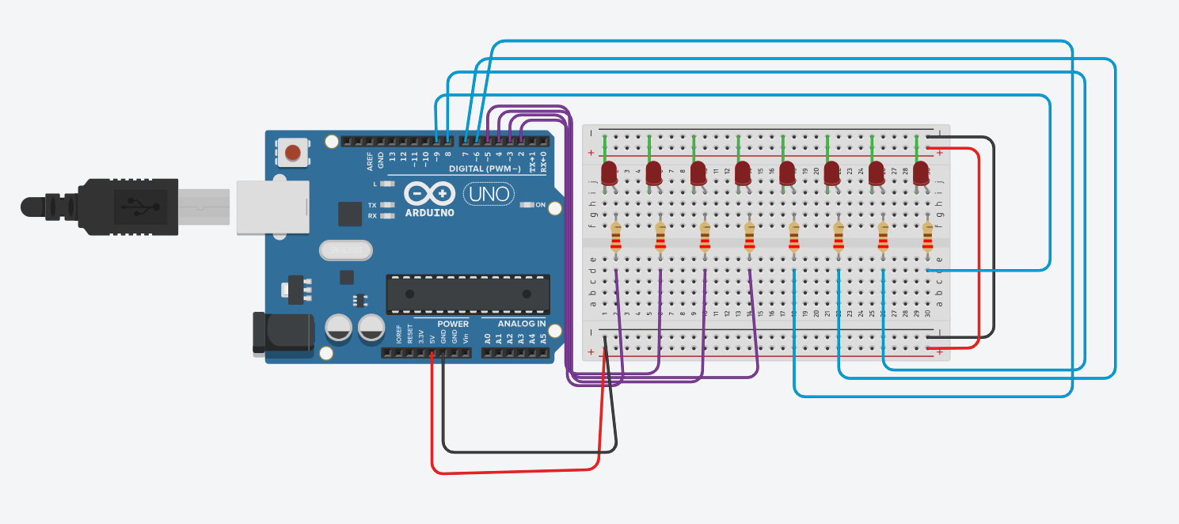

TINKERCAD Link:

https://www.tinkercad.com/things/bwyq6GN9aVA-lab-3/editel?sharecode=8XLniHgNaSzfW_8hZZUAdSPwQsohYw0fD2ac0-UCGdI

Conclusion

An array of eight LEDs is controlled by the accompanying Arduino script to display the binary representation of decimal values from 1 to 255. The required pins are configured by the code, and variables that will be used to track the current decimal value and LED state are initialized. The main loop outputs the decimal value to the serial monitor while also continually incrementing the decimal value, translating it into binary, and displaying it on the LEDs. The condition of the LEDs is checked when the decimal value hits 255. If they are all off, it enters an infinite loop to stop the program from running and signals that all LEDs are now off by briefly turning them all on before turning them all off. This happens if they are all on. With the help of this code, you can easily and clearly see how decimal values are represented in binary on an array of LEDs.